University Sarajevo School of Science and Technology

Hrasnička cesta 3a,

71 000 Sarajevo,

Bosnia and Herzegovina

Design and Implementation in Web Environment

ZENdrive – ticket purchasing website

*- Documentation -*

Professor: Students:

Bakir Husović Zijah Mahmutbegović

Ema Mandura

Nermana Šantić

Sarajevo, January 2018.

***ABSTRACT***

For the purpose of this project we have created a website that enables users to book bus tickets online. The website was designed using HTML, CSS, PHP and JavaScript and we have connected it to a database using MySQL. The website has registration and login forms that provide access to the users' accounts. The account belonging to the admin has the possibility of reading information about all the routes, adding cities, editing the prices and deleting routes. All CRUD functions are implemented through this option. The idea is that the user chooses an origin city, a destination city and the date on which he wishes to take the bus. Then by submitting this form, a timetable including routes that meet those requirements gets displayed. The user chooses a time that best suits him and buys the ticket that then gets transferred into his wallet, where a history of all his previously purchased tickets is kept. The website also has a Destinations panel where more information about cities that transportation is offered to can be found. On a separate panel there is also more information about the company, its goals and contact information. We have come across some problems regarding interaction with the database, as some SQL queries did not work as expected and therefore left some functionalities of the website incomplete. Overall, we have managed to create a dynamic website that puts to use most of the material we have gone over in our Web Design and Implementation course.

***INTRODUCTION***

Our project is based on a website for a company called ZENdrive. ZENdrive is a ticket purchasing company that allows its customers to book bus tickets online. By registering on the website, the user gets their personal profile that they can use to buy an unlimited number of tickets for different routes. We are going to explain how accomplished this in the next section.

***PROJECT IMPLEMENTATION***

1. **Database**

As the first step of our project we have created a database. Then we connected it to the website so we can send data both ways – from the database to the website and from the website to the database.

*Registration (*from the website to the database)

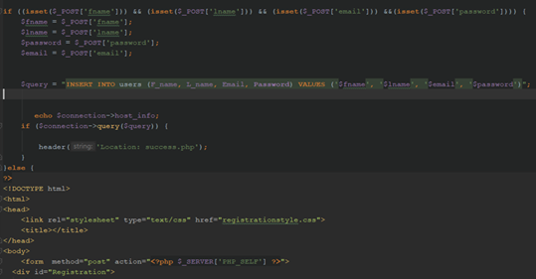

This screenshot shows the use of PHP for the creation of the register function. It uses an if conditional statement to check if information was typed into the provided fields, and if it was, the entered data gets inserted into the users table in the database.

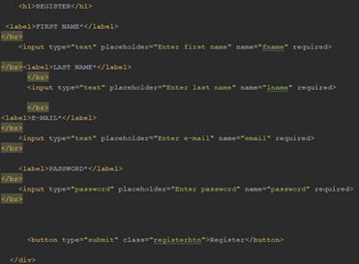

This screenshot shows the HTML form for the registration. We have created four input fields that are used to collect registration information from the user.

*Login (*from the database to the website)

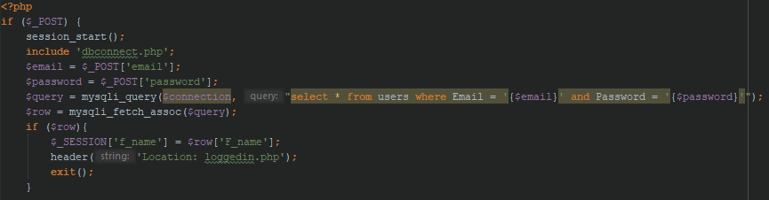

This is the PHP code for login. It starts by checking if an input was made. Then it checks if there is a user in the database matching the entered data values. If there is, it sends the user to the loggedin.php page.

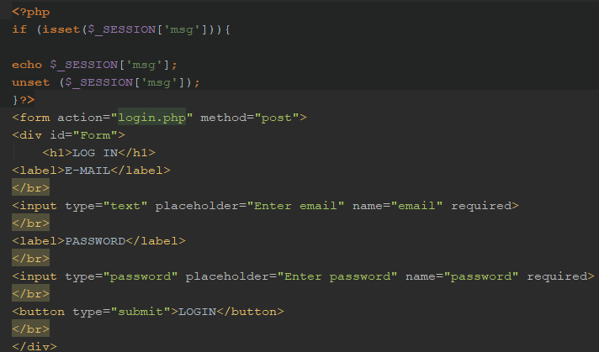

This is a HTML form for login that has input fields for e-mail and password and a submit button that finishes the login.

1. **CRUD functions**

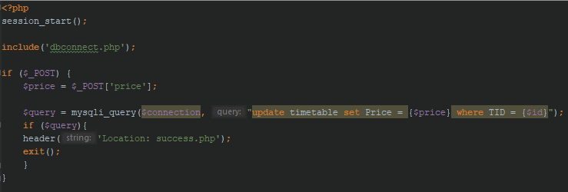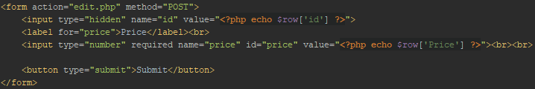

This part of the PHP code handles the edit function. It allows the admin to change the ticket price for the specific primary key in the timetable table. If it is executed correctly, the admin is transferred to a success page.

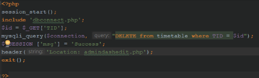

This PHP code allows the admin to delete a route from the timetable table by primary key.

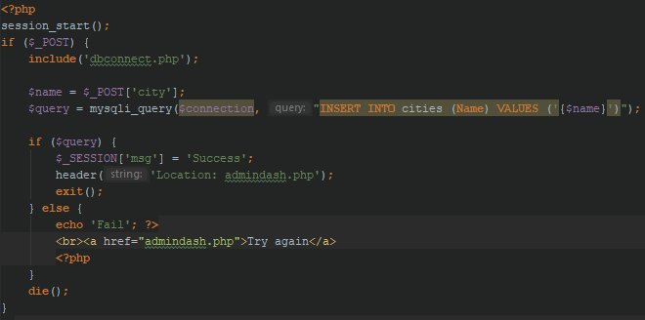

This is the PHP code for adding a city to the cities table.

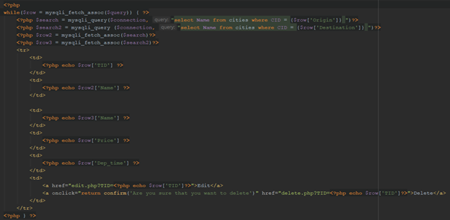

This PHP code uses a while loop to go through the database and display the routes timetable. First it fetches the name of the city corresponding to the given CID that it then echoes to the screen in a HTML table.

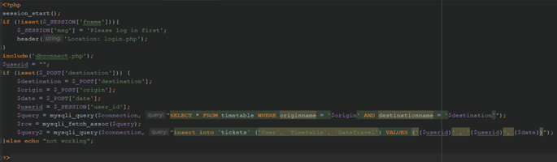

This part of the PHP code is used for booking the actual ticket. It selects a route from the timetable where the origin and destination city match the ones the passenger has selected and then when the Buy option is chosen, it saves the route with the ID of the currently logged in user to the tickets table.

***CONCLUSION***

This project has given as an opportunity to put the skills we learned in our Web Design and Implementation course to practical use in a real-life environment. We have managed to implement most of the options we went over in the class and also expanded our knowledge by doing research and finding creative solutions for the ideas we had in mind for our website. We have faced a few difficulties, mostly regarding how the website works together with the database. However, this has helped us understand the complexity of web design and the challenges of working on projects that have an actual purpose and require dynamism. All in all, we are satisfied with the outcome of our project and are fully aware of its short-comings that we hope to improve in the future.

***REFERENCES***

1. W3schools.com. (2018). W3Schools Online Web Tutorials. [online] Available at: https://www.w3schools.com/ [Accessed 13 Jan. 2018].
2. Ullman, L. (n.d.). PHP and MySQL for dynamic web sites.
3. Castro, E. and Hyslop, B. (n.d.). HTML and CSS.
4. Stackoverflow.com. (2018). Stack Overflow - Where Developers Learn, Share, & Build Careers. [online] Available at: https://stackoverflow.com/ [Accessed 13 Jan. 2018].
5. CodePen. (2018). Style a Select Box Using Only CSS. [online] Available at: https://codepen.io/ericrasch/pen/zjDBx [Accessed 13 Jan. 2018].
6. Coderwall. (2018). Fully custom select box, simple css only (Example). [online] Available at: https://coderwall.com/p/w7npmq/fully-custom-select-box-simple-css-only [Accessed 13 Jan. 2018].
7. Jetbrains.com. (2018). Meet PhpStorm - Help | PhpStorm. [online] Available at: https://www.jetbrains.com/help/phpstorm [Accessed 13 Jan. 2018].